Daily routines

- Write the routines under each picture.

I wash | I leave for school | I wake up | I go to bed
I have supper | I do my homework | I have a shower | I go shopping
I brush my teeth | I get up | I have breakfast | I go downstairs
I have lunch | I come home from school | I watch TV | I get dressed

7.10

1) ……………………………………… 2) ……………………………………… 3)……………………………

4) ……………………………………… 5) ……………………………………… 6) ………………………
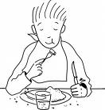

7) ……………………………………… 8) ……………………………………… 9) …………………………

1 11)

10) ……………………………………… 11) ……………………………………… 12) ……………………………

13) ……………………………………… 14) ……………………………………… 15) ……………………………

16) ………………………………………

What time is it ?
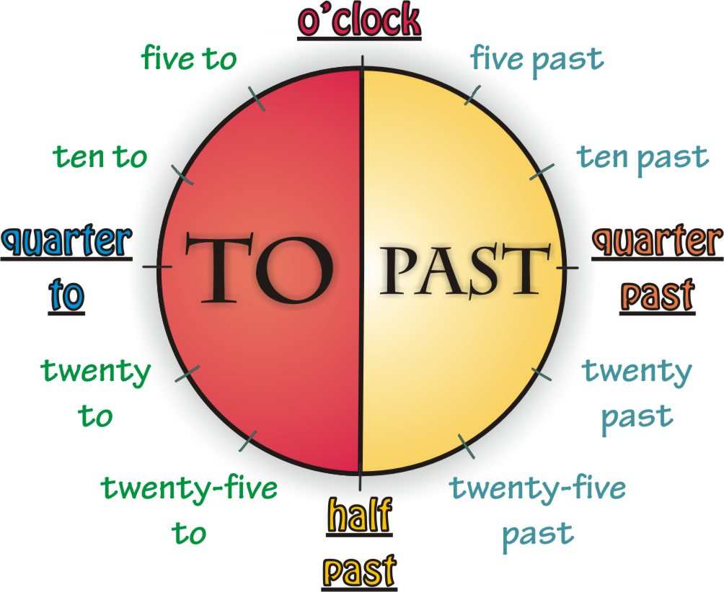

Exemples :

Il est 8h05 It’s five past eight
Il est 3h15 It’s quarter past three jusqu’à la 1/2h (comprise)
Il est 2h20 It’s twenty past two = l’heure en cours
Il est 1h30 It’s half past one.

Mais:

Il est 4h35 It’s twenty-five to five
Il est 5h45 It’s quarter to six au-delà de la 1/2h
Il est 9h55 It’s five to ten = l’heure qui suit
Remarques:
- En anglais, les heures ne vont que de 1 à 12 (et pas de 1 à 24)
pour préciser s’il s’agit du matin, on ajoute A.M. 3h = 3 a.m.
pour préciser s’il s’agit du soir, on ajoute P.M. 15h = 3 p.m.

- Lorsqu’il est presque l’heure pile, on dira « about » ou « just before » ou « just after »
it’s about 3 o’clock (+/- 3h)
it’s just before 3 o’clock (2h58)
it’s just after 3 o’clock (3h02)
- Write the time in letters
8.45 : ………………………………………………………………………………………………
14.00 : ……………………………………………………………………………………………
24.00 : ……………………………………………………………………………………………
5.30 : …………………………………………………………………………………………………
7.18 : …………………………………………………………………………………………………
2) What time is it on the clocks ?
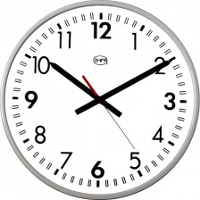
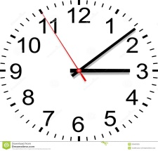
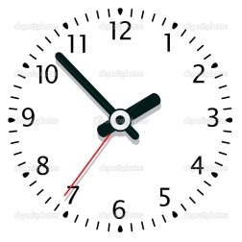
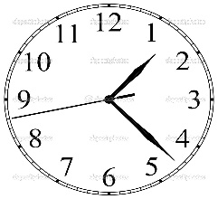
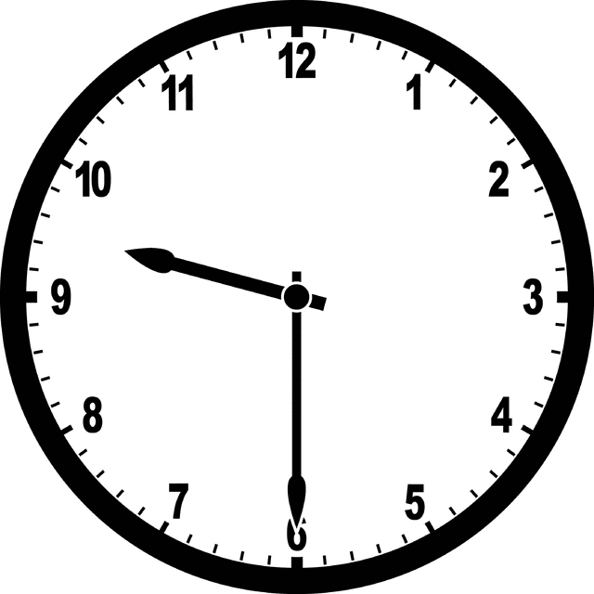

- What time is it? Listen to your teacher

Simple present
To work

+ | - | ?
I ……………………………………………………  you …………………………………………………  he, she, it ………………………………………  we …………………………………………………  you …………………………………………………  they ……………………………………………… | I ……………………………………………………  you …………………………………………………  he, she, it ………………………………………  we …………………………………………………  you …………………………………………………  they ……………………………………………… | ………………………………………………………………  ………………………………………………………………  ………………………………………………………………  ………………………………………………………………  ………………………………………………………………  ………………………………………………………………

Exercices
- Fill in the gaps: = affirmative form, = negative form

- My brother ……………………………. ( - to work) a lot for his exams.
- I ………………………. ( - to like) films but I …………… very often ………….. ( - to go) to the cinema.
- What time ………………. you …………………. ( - to wake up) in the morning?
- My friends ……………………………………… ( - to go) clubbing, they’re too busy.
- …………………….. you ……………………. ( - to remember) your last holidays?
- Where ………………. Your father ………………………..? ( - to work)
- What ……………. these pupils ……………….. ? ( - to do)
- My mother ……………………………… ( - to sing) very well, but she ………………….. ( - to sing) in a choir.
- ……………………………. you …………………………. ( - to have) a pen?
- They …………………. ( - to like) football but they ………………………. Very often ……….. ( - to watch) it on TV.
- ……………… you ………………….. ( - to read) a newspaper every day?
- My girlfriend …………………………… ( - to wash) her hair every day.
- I ………………………….. ( - to have) lunch at home. I ………………………… ( - to eat) at school.
- …………………… Ben and you always ……………………. ( - to go) to school together?
- Babies sometimes ………………………….. ( - to cry) at night.

- Ask the questions
Ex : He plays rugby every Friday -> When does he play rugby ?

- We live in Glasgow. -> ………………………………………………………………………………………………
- My father works in a factory. -> ……………………………………………………………………………
- I get up at 6 o’clock every day. -> …………………………………………………………………………
- My sister and I come to school on foot. -> ……………………………………………………
- He does exercises every morning. -> ……………………………………………………………………
- They usually have lunch at school. -> …………………………………………………………………
- I have cornflakes and milk for breakfast. -> ……………………………………………………
Lewis Hamilton
Some of my friends think I have an intense daily routine, but I like it! I usually get up at 6 o’clock in the morning, after my alarm clock wakes me up. First, I brush my teeth, and shave and wash my face. Then I get dressed and go downstairs to have breakfast with my wife Nicole. I always have coffee, cereals and lots of fruit. I take my Porsche Boxster to go to work because I like driving of course and I always arrive at my office before 8:00. I’m never late for work! Five o’clock is my favourite time of the day because I see my wife again. We don’t have any children but we have a dog. Its name is Schumi! I eat dinner with my wife at around eight p.m. We often go to the restaurant because I don’t like cooking at all! And after that, I hang out with my wife at home. We really enjoy watching our favourite TV programs together. We like watching shows about travel and racing ;) However, two or three times a week, I do exercise in the evening, so I can stay strong and healthy. I think this is very important! Finally, at about 10:30, I go to bed, read for a while, and then fall asleep. On weekends, I love to fly airplanes! It’s a different hobby!

Reading comprehension
Retrouve 15 éléments en français concernant la routine de Lewis Hamilton.

- …………………………………………………………………………………………………………………
- ………………………………………………………………………………………………………………..
- …………………………………………………………………………………………………………………
- …………………………………………………………………………………………………………………
- …………………………………………………………………………………………………………………
- …………………………………………………………………………………………………………………
- ………………………………………………………………………………………………………………..
- …………………………………………………………………………………………………………………
- …………………………………………………………………………………………………………………
- …………………………………………………………………………………………………………………
- …………………………………………………………………………………………………………………
- ………………………………………………………………………………………………………………..
- …………………………………………………………………………………………………………………
- …………………………………………………………………………………………………………………
- …………………………………………………………………………………………………………………

- Put the following questions at the 3rd form
What time do you wake up?
What time do you get up?
What do you eat for breakfast?
What time do you have a shower?
What time do you have a bath?
What time do you get dressed?
What time do you leave for school?
What time do you start school?
What time do you have lunch?
Which lessons do you have?
What time do you finish school?
What time do you go back home?
What do you do after school?
What time do you have dinner?
What time do you watch TV?
What time do you go to bed?

- Describe your daily routine (10 sentences)
…………………………………………………………………………………………………………………………………………………………………………………………………………………………………………………………………………………………………………………………………………………………………………………………………………………………………………………………………………………………………………………………………………………………………………………………………………………………………………………………………………………………………………………………………………………………………………………………………………………………………………………………………………………………………………………………………………………………………………………………………………………………………………………………………………………………………………………………………………………………………………………………………………………...

- Describe Tom’s routine

6.30 | Se lever
6.45 | Prendre une douche
7.00 | S’habiller
7.15 | déjeuner
7.30 | Quitter la maison pour aller à l’école
8.25 | Commencer l’école
12.00 | Diner
16.00 | Finir l’école
16.30 | Faire ses devoirs
18.00 | Souper
19.00 | Regarder la TV
21.30 | Aller dormir

………………………………………………………………………………………………………………………………………………………………………………………………………………………………………………………………………………………………………………………………………………………………………………………………………………………………………………………………………………………………………………………………………………………………………………………………………………………………………………………………………………………………………………………………………………………………………………………………………………………………………………………………………………………………………………………………………………………………………………………………………………………………………………………………………………………………………………………………………………………………………………………………………………………………………………………………………………………………………………………………………………………………………………………………………………………………………………………………………………………………………………………………………………………………………………………………………………………………………………………………………………………………………………………………………………………………………………………………………………………………

« Find someone who… »
Speaking

Has a motorbike
Eats a hamburger once a week
Has a girlfriend / boyfriend
Can drive a car
Sometimes drinks beer
Likes English
Goes to Tomorrowland
Comes from Africa
Has a drone
Likes Rihanna

Lisa’s two jobs
Ecoute l’interview de Lisa et explique sa routine en français. Donne au moins 10 éléments.

